Welcome to Outlook Analyzer!  
  
This document assumes that you have a basic understanding of (1) how to install and run a Python interpreter, (2) how to execute a Python program, and (3) use the command line to execute Outlook Analyzer.

If you are unfamiliar with **installing Python** and need to, please refer to this walkthrough [here](https://realpython.com/installing-python/#how-to-install-python-on-windows).

If you are unfamiliar with **loading a python program**, please refer to this walkthrough [here](https://www.pythonforbeginners.com/development/how-run-your-python-scripts). Follow Section 1 if running Outlook Analyzer in the command prompt, Section 2 if running with Anaconda, or Section 7 if running with a non-Anaconda based IDE.

If you are unfamiliar with **running command lines** in a command prompt, please refer to this walkthrough [here](https://learn.adafruit.com/using-python-on-windows-10/command-line-python).

# Installing Dependencies

If you are unfamiliar with running command line arguments, check out the link above for an intro to using command prompts prior to following the instructions below.

|  |
| --- |
| ***ANACONDA USERS:*** Sadly, Anaconda's environment defaults to an older verison of pywin32 and breaks a key .DLL path when attempting to update to versions >228. **BEFORE** following below pip install instructions, remove the "pywin32==[version]" line from your requirements.txt file and save, then follow the below instructions. **THEN** you will need to install the pywin32 package by entering "conda install pywin32" into your command prompt after the other packages have been installed. See [this link](https://github.com/mhammond/pywin32/issues/1865) and [this link](https://stackoverflow.com/questions/60750197/pywin32-importerror-dll-load-failed-the-specified-module-could-not-be-found) for further details on this issue with Anaconda.  **If you already have pywin32 installed** before working with this project, you should first uninstall Anaconda's older version using "pip uninstall pywin32" then execute "conda install pywin32".  **Failing to follow these instructions may break your environment.** |

To install dependent packages:

(1) Open command prompt

(2) Navigate to the directory of the Outlook Analyzer project

(3) Enter "pip install -r requirements.txt" into your command prompt

(4) Press Enter

## Running script without command line options

Enter the below command in your command prompt.

The next screen will help you determine which emails Outlook Analyzer should extract and examine:

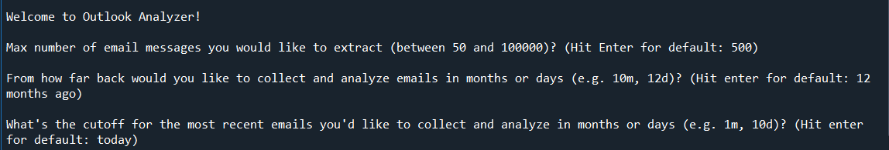

As you can see above, you can adjust Outlook analyzer in three key ways:

1. Set a maximum number of emails to extract; value must be between 50 and 100,000 emails
2. Set how far in the past from which to extract emails (in months or days)
3. Set a the most recent point in time from which to extract emails (in months or days)

If you are running Outlook Analyzer with optional command lines, you can also specify the path and filename of your report (see next section for more detailed instructions).

## Running script with optional command line options

You can get help with -h or –help:

Below are some example command formats for running Outlook Analyzer with command line options:

If you only enter some but not all of the optional command line arguments then script will ask for the remaining arguments for number, start and end. If no command line arguments for "open" or "output" are provided, then the defaults are used. For defaults, the report will be saved to 'C:\WINDOWS\Temp\outlook_analyzer_report.pdf' and the pdf file will be opened after script runs.

## Generated Report Example

Outlook Analyzer will produce a PDF displaying some key metrics based on your inbox data. Below is an example:

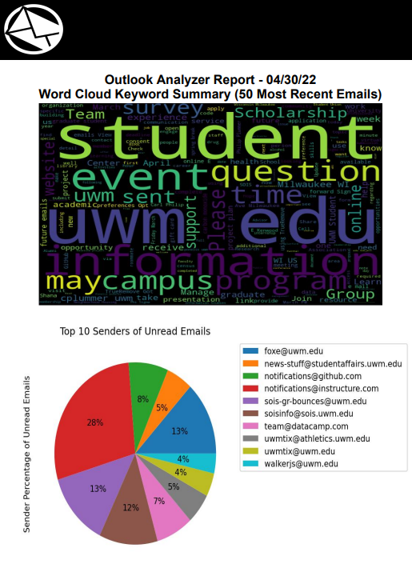

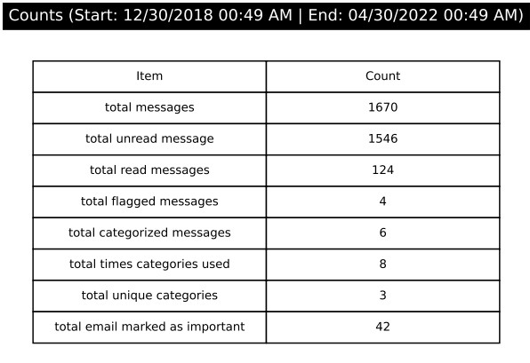

## FAQ

**Q:** Why is my email Inbox only going back 12 months?

**A:** Outlook defaults to use cached exchange mode with only 12 months available. To change this, you can go into the Outlook Desktop client, choose File > Account Settings > Account Settings... > on Email tab, choose the Account > Click "Change..." or Double click the Account > Deselect "Use Cached Exchanged Mode to download email to an Outlook data file" > Change the slider bar to indicate how many years past to download email.

**Q:** Where can I get Microsoft Mailterm object Documentation

**A:** Please see here: <https://docs.microsoft.com/en-us/office/vba/api/outlook.mailitem>

**Q:** How do I solve “Missing C++ Build tools on Windows 10” message

**A:** Try these steps

1. Download build tools from https://visualstudio.microsoft.com/visual-cpp-build-tools/
2. Download the build tools
3. Install the build tools with the following components: Windows 10 SDK AND C++/CLI support